Best of Tanzania

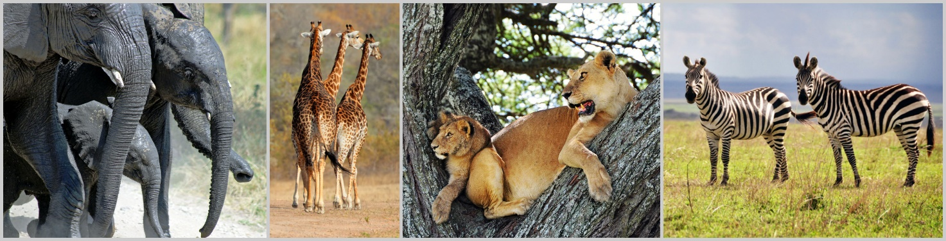

Scheduled lodge safari | minimum 2, maximum 7 people | guaranteed window seat

Day 1 | 1 N | Tarangire Area | Lake Burunge Tented Lodge | FB
Day 2 | 1 N | Lake Manyara Area | Kirurumu Manyara Lodge | FB
Day 3 – 4 | 2 N | Serengeti National Park | Kati Kati Tented Camp | FB
Day 5 – 6 | 2 N | Karatu | TWC Adventure Lodge | FB
Day 7 | - | Arusha

Included: transport in a 4x4 safari vehicle | professional, English-speaking guide | 6 nights’ stay in lodges and tented camps (depending on availability, accommodation of a similar standard will be booked) | meals according to the itinerary | mineral water | activities as per itinerary | all national park fees | Flying Doctors insurance (AMREF) during the safari

Excluded: flights (international and domestic) | meals not indicated in the itinerary | alcoholic and soft drinks | optional activities | tips | personal expenses | visa fees | travel insurance

Detailed Itinerary

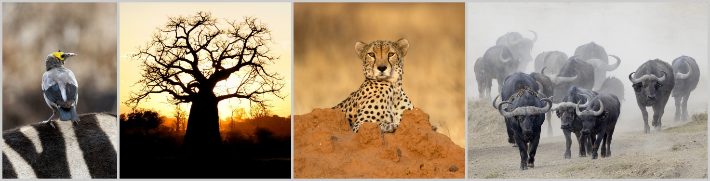

Day 1 | Arusha – Tarangire National Park
Distance approx. 150 km; driving time approx. 2-3 hours

After a safari briefing in the morning and an approximate two-hour drive you will arrive at the Tarangire National Park. Giant baobab trees, bush savannah and the seasonal marshes add to the wonder of this nature reserve. The Tarangire National Park is considered as one of the best places to view elephants up close. The park is also home to buffaloes, zebras and wildebeests which are always closely followed by a range of predators such as lions. Leopards are seen now and then but cheetahs are rarely spotted. From the open roof of the safari vehicle you will be able to absorb the landscape and watch the animals. In the late afternoon you will leave the park and drive to the Lake Burunge Tented Lodge, where you will overnight.
Lunch | Dinner

Day 2 | Tarangire Area – Lake Manyara National Park
Distance approx. 100 km; driving time approx. 1-2 hours

After breakfast you will travel from the Tarangire Area to the Lake Manyara National Park. The park is known for its over 400 bird species, primate-filled forests and grassy plains. A large area of the park is covered by the alkaline Lake Manyara, the seasonal breeding grounds for large colonies of flamingos and many more waterfowls. The park is also home to giraffes, hippos, wildebeests, impalas and groups of noisy monkeys and baboons. After an extensive game drive you will travel to the Kirurumu Manyara Lodge, where you will spend the night.
Breakfast | Lunch | Dinner

Day 3 | Lake Manyara Area – Serengeti National Park
Distance approx. 200 km; driving time approx. 4-6 hours

After breakfast, you will travel via the cooler highlands towards the southern Serengeti and at midday you will reach the plains of the Serengeti National Park. This park is the largest in Tanzania and has a diversity of habitats and landscapes – short grass plains, savannah, thick bush, swamps and lakes. Bizarre rock formations called kopjes dot the grassy landscape where predators are often seen. The Serengeti is famous for the yearly migration when hundreds of thousands of wildebeests and zebras trek to find fresh grass and water. You will spend the night at the Kati Kati Tented Camp inside of the park.
Breakfast | Lunch | Dinner

Day 4 | Serengeti National Park

The entire day is dedicated to game viewing in the Serengeti National Park. The areas that you visit will depend upon where the migrating herds are. Predators usually follow closely behind the trekking animals and include lions, leopards (in the acacia trees) and cheetahs. During the short rainy season in November and December the herds move from the hills in the north to the plains in the south. During the longer rainy season from April to June they return up north. As the migration is completely dependent on the yearly rainfalls, the location of the herds may vary from year to year but your guide will know where to locate the animals and where to see them best. You will spend another night at the Kati Kati Tented Camp.
Breakfast | Lunch | Dinner

Day 5 | Serengeti National Park – Karatu – Coffee Walk
Distance approx. 170 km; driving time approx. 4-6 hours

On your outward journey to the park gate, you will enjoy some more game viewing before you leave the Serengeti National Park in the early afternoon to continue your journey to the Ngorongoro Conservation Area. As soon as you reach the edge of the Ngorongoro Crater, you will see the giant caldera below – a breath-taking view. You will leave the Ngorongoro Conservation Area and drive to Karatu in the Ngorongoro highlands. Here you will join a walk in the coffee plantation to learn more about the cultivation and processing of coffee. You will spend the night at one of the three beautifully located Tanganyika Wilderness Adventure Lodges.
Breakfast | Lunch | Dinner

Day 6 | Karatu – Ngorongoro Crater – Karatu
Distance approx. 50 km; driving time approx. 1-2 hours

Rise and shine! After breakfast at daybreak you travel back to the Ngorongoro Conservation Area before you drive down into the crater. The massive collapsed volcano is home to over 25,000 mammals ranging from the Big Five – lion, elephant, buffalo, rhino and leopard – to spotted hyenas, rare wild dogs and some of the more than 500 bird species of the area. After an extensive game drive and a picnic for lunch, you will leave the caldera in the afternoon and return to your Tanganyika Wilderness Adventure Lodge to spend another night.
Breakfast | Lunch | Dinner

Day 7 | Karatu – Arusha
Distance approx. 160 km; driving time approx. 2-3 hours

After a leisurely breakfast, you will travel back to Arusha where you will arrive around midday. You will be dropped off in the city centre or at the airport.
Breakfast | Lunch

