Cape’s Culinary Delights

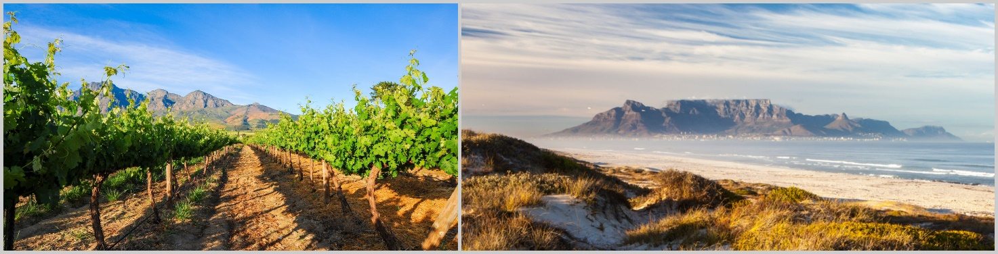
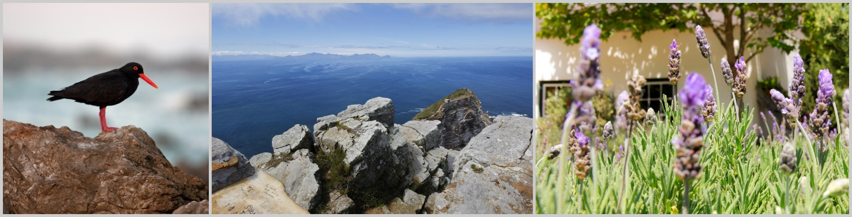

Private lodge tour | departure day: Saturday

Day 1 – 2 | 2 N | Stellenbosch | WedgeView Country House | B
Day 3 | 1 N | Swellendam | Augusta de Mist Country House | B
Day 4 | 1 N | Swellendam | Augusta de Mist Country House | HB
Day 5 – 6 | 2 N | Tulbagh | The Tulbagh Boutique Hotel | HB
Day 7 – 9 | 3 N | Cape Town | The Three Boutique Hotel | B
Day 10 | - | Cape Town

Included: transport in an air-conditioned minibus| professional, English-speaking guide | 9 nights’ stay in lodges, hotels and guesthouses (depending on availability, accommodation of a similar standard will be booked) | meals according to the itinerary | activities as per itinerary | all entrance fees

Excluded: flights (international and domestic) | drinks and meals not indicated in the itinerary | optional activities | tips | personal expenses | visa fees | travel insurance

Detailed Itinerary

Day 1 | Stellenbosch and Franschhoek
Driving distance approx. 80 km; driving time approx. 1-2 hours

In the morning, you meet your guide for your upcoming trip in Stellenbosch and embark on your culinary adventure with a drive to Franschhoek, a gem located in South Africa’s winelands. Your guide knows the small town like the back of his hand and will take you on a tour, sharing his local knowledge with you. Franschhoek is a great place for your first lunch together (at own cost) and will

give you an idea of what to expect on this special tour around the Cape region. Afterwards, you drive back to Stellenbosch where you will arrive at the WedgeView Country House. Make yourself at home and relax a little before you enjoy your first wine tasting at a selected wine farm close by in the late afternoon. Your first taste of the unique wines of South Africa. You overnight at WedgeView Country House.

Day 2 | Stellenbosch and Surrounds

Breakfast surely is an important meal of the day. However, today, we’d suggest you don’t dig in too enthusiastically: you will visit one of the popular Food & Farmers’ Markets close to Stellenbosch this morning. Here, you will not only find a colourful mix of quality artisanal and handcrafted products, but also delicious food and drinks. Look forward to local delicacies, various wines and craft beers. South Africa’s locals love these markets and you will taste their passion and love in every bite and sip. With a satisfied tummy and many impressions to process, you have the afternoon to relax. Look forward to an exclusive wine tasting followed by a delicious dinner (at own cost) at a restaurant in Stellenbosch. You spend another night at the WedgeView Country House.
Breakfast

Day 3 | Stellenbosch – Hermanus – Swellendam
Driving distance approx. 300 km; driving time approx. 4 hours

Today, you will leave the winelands for a short while to make your way to the ocean. Driving along one of the most stunning coastal roads of the country you can enjoy panoramic views of the Atlantic Ocean. The road takes you along the False Bay and will on some stretches get you so close to the water you might want to jump right in. In Hermanus, the centre of the whale region, you have time to go for a little stroll – depending on the season, you might get lucky and see whales even from shore. Together with your guide, enjoy lunch at an excellent fish restaurant right by the ocean (at own cost). The region is well-known for making delicious cheeses and you can try some of them at a tasting when visiting a cheese farm in the afternoon. Your next stop is your home for the next two nights: you make your way to Augusta de Mist Country House in the small town of Swellendam. Over a delicious dinner at a local restaurant (at own cost) your exciting day comes to an end.
Breakfast

Day 4 | Swellendam and Surrounds

Wake up to birds chirping in the morning sun and look forward to a day in Swellendam. After breakfast, put on some comfy shoes and together with your guide make your way to the close-by Marloth Nature Reserve, our insider’s tip in this region. Explore this wonderful nature reserve on various hiking trails catering for different lengths and fitness levels. Enjoy your time in nature, learn about the local plants and look out for birds and small animals. During the whale season (June to November) we recommend visiting the beautiful De Hoop Nature Reserve instead. Surrounded by white dunes, you can let your gaze wander across the horizon, keeping an eye out for the gentle giants of the ocean. Back in Swellendam, you can spend the afternoon at your leisure. Take a little nap or accompany your guide on a walk around the historical town of Swellendam. In the evening, a first-class menu at Augusta’s African Kitchen awaits you. You spend another night at Augusta de Mist Country House.
Breakfast | Dinner

Day 5 | Swellendam – Tulbagh
Driving distance approx. 150 km; driving time approx. 2 hours

Today, you will explore another idyllic town at the heart of South Africa’s winelands. Following a panoramic route, passing Robertson and many wine farms, you make your way to Tulbagh. Grape vines as far as your eye can see line the streets. Around lunch time, you arrive at the Tulbagh Boutique Hotel, your home for the next two nights. Enjoy a relaxed lunch on the deck of the hotel (at own cost) before you head to your first wine tasting. You visit one of the most well-known wine farms in the region: Saronsberg Cellar. Its magnificent gardens are decorated with sculptures by local artists, inviting you to explore and linger. Take a seat on the deck and enjoy the stunning views across the pond, the grape vines and the impressive mountains while you taste the local wines. In the late afternoon, you head back to Tulbagh. Take a dip in the swimming pool before you enjoy a 3-course dinner at the hotel’s Olive Terrace Bistro.
Breakfast | Dinner

Day 6 | Tulbagh and Surrounds

You can’t miss out on a classic MCC-tasting on your culinary trip! After a relaxed breakfast, your first destination of the day is the Twee Jonge Gezellen wine farm, where the well-known Krone MCC is handcrafted. MCC is short for Méthode Cap Classique and refers to sparkling wines which can be compared to Champagnes, created through bottle-fermentation. Enjoy the bubbles on your tongue, while you let your gaze wander across the idyllic landscape. Afterwards, you go to the farm Lemoendrif, the origin of the award-winning Oakhurst olive oil. Taste the different olive oils, delicious tapenades and of course the Oakhurst olives. For lunch (at own cost) you stop in at a lovely restaurant or café in Tulbagh. After a welcomed rest, you visit the Lemberg Estate in the afternoon. At this small boutique wine farm just five minutes from Tulbagh, you can taste Pinot Noir, Pinotage, Shiraz, Sauvignon Blanc and Hárslevelü wines and learn to distinguish the characteristics of each type of grape. You enjoy dinner and another night at the Tulbagh Boutique Hotel.
Breakfast | Dinner

Day 7 | Tulbagh – Helderberg Reserve – Cape Town
Driving distance approx. 170 km; driving time approx. 2-3 hours

After an early breakfast, you leave the Tulbagh Valley behind. Your first destination is the Helderberg reserve close to Somerset West. This nature reserve with its impressive West Peak is a very popular spot with locals for an outing in nature. Go for a short hike and enjoy the views across the False Bay and all the way to Table Mountain; you may even see Cape Point if the weather permits. Enjoy lunch (at own cost) at the close-by Vergelegen Estate. From here, it’s only a short drive to Cape Town and your accommodation. Spend the afternoon at your leisure. In the evening, Cape Town and its many excellent restaurants await you for dinner (at own cost). Your home for the next three nights is The Three Boutique Hotel.
Breakfast

Day 8 | Cape Town

Over the coming two days, you will get to know one of the most beautiful cities in the world. On top of the classic sights, you can look forward to many lovely nooks and corners when exploring Cape Town. In the morning, we start with a visit to Table Mountain. At this time of the day, chances for clear views are best. While the cable car takes you higher and higher, the view across the bay and City Bowl of Cape Town opens up. Looking south, you can see the Cape Peninsula at your feet. Back on the ground, enjoy the vibrant Cape Town feeling on a walk around the city. Your guide also takes

you to places which tell the moving history of South Africa. You then head to the world-famous V&A Waterfront. Explore the working harbour at your own pace, take a stroll and shop for souvenirs. In the evening, a highlight awaits: a dinner show of the highest quality. Let yourself get carried away and experience a very special evening you will remember for a long time to come. You spend the night at The Three Boutique Hotel.
Breakfast | Dinner

Day 9 | Cape Peninsula
Driving distance approx. 150 km; driving time approx. 3-4 hours

After an exciting night out, you start your day in no rush and together with your guide you embark on a day trip around the Cape Peninsula. Driving along the coastal road, you pass by picturesque bays and idyllic fishing villages. Open up the window and enjoy the fresh sea breeze. The Cape of Good Hope, the southwestern-most point of the African continent, and Cape Point are two of the most beautiful sights of South Africa. You will be mesmerised by the spectacular panoramic views across the vast ocean. Of course, your trip includes a visit to the Jackass penguin colony at Boulders Beach in Simon’s Town as well. End this exciting day with a last dinner (at own cost) at a typically South African restaurant. Test, which wine pairs best with traditional South African cuisine. You spend one more night at The Three Boutique Hotel.
Breakfast

Day 10 | Cape Town

The tour ends after breakfast. It is time to wish your guide farewell and continue according to your individual travel plans or head back home. Hamba kakuhle, totsiens and Goodbye!
Breakfast

