South Africa – Experience the South

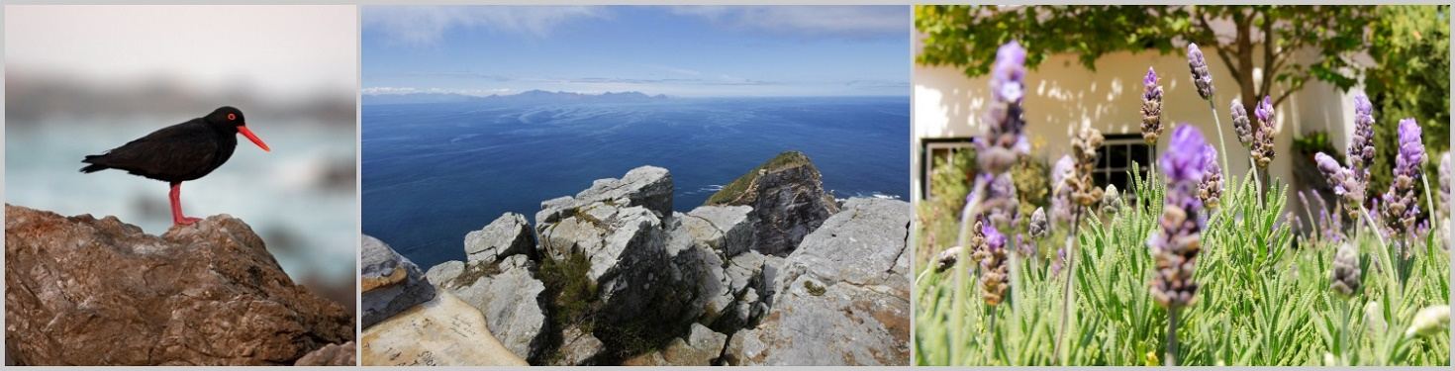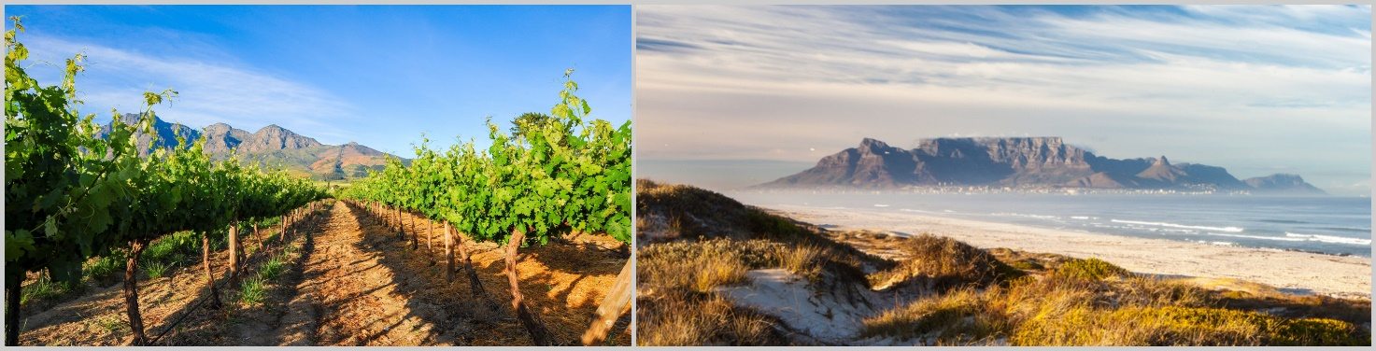

Scheduled lodge tour | minimum 2, maximum 10 people | 14 days from £1975 per person sharing

Day 1 – 2 | 2 N | Cape Town | 40 on Burg | B
Day 3 – 4 | 2 N | Stellenbosch | Auberge Rozendal | B
Day 5 – 6 | 2 N | Hermanus | Whale Rock Lodge | B
Day 7 | 1 N | Oudtshoorn | Thabile Lodge | HB
Day 8 – 9 | 2 N | Wilderness | Moontide Guest Lodge | B
Day 10 – 11 | 2 N | Storms River | At the Woods Guesthouse | B
Day 12 – 13 | 2 N | Addo | De Old Drift Guest Farm | HB
Day 14 | - | Port Elizabeth

Included: transport in an air-conditioned minibus| professional, English-speaking guide | 13 nights’ stay in lodges, rest camps and guesthouses (depending on availability, accommodation of a similar standard will be booked) | meals according to the itinerary | activities as per itinerary | all national park fees

Excluded: flights (international and domestic) | meals not indicated in the itinerary | alcoholic and soft drinks | optional activities | tips | personal expenses | visa fees | travel insurance

Detailed Itinerary

Day 1 | Cape Town
Distance approx. 40 km; driving time approx. 1 hour

Your South African adventure starts upon arrival at Cape Town International Airport. Welcome to one of the most beautiful cities in the world! During the drive to your lovely guesthouse in the heart of the city, you will get a first impression of what to expect in the coming days. Make yourself at home before you meet your fellow travellers and guide in the evening. You will get to know each other over dinner (at own cost) and receive a thorough briefing about your upcoming trip. You will overnight at the centrally located 40 on Burg.

Day 2 | Cape Town

Today you explore the city of Cape Town. If weather permits, your first destination for the day is Table Mountain. Using the cable car, you make your way to the top of the landmark of the “Mother City” at more than 1000 metres above sea level. Enjoy the views across Cape Town and the seemingly endless ocean as well as the Cape Peninsula. Afterwards, you explore the city’s history together with a local guide. Special focus lies on District Six, formerly known for its vibrant, multicultural vibe. During the Apartheid years, its inhabitants were forcibly removed and resettled in townships, while the houses in District Six were demolished. You will also visit the well-known Victoria & Alfred Waterfront. Stroll around the old harbour and experience its unique charm and bustling activities. You will spend another night at 40 on Burg.
Breakfast

Day 3 | Cape Town – Stellenbosch
Distance approx. 150 km; driving time approx. 2 hours

Bags packed you make your way to Cape Point in the morning. Travelling along the pristine coastline, you reach the Cape of Good Hope. The legendary Cape of Storms, as it was known amongst sailors, is not only notorious for its rough waters but even more so for its natural beauty. From the lighthouse and many viewing points along the way, enjoy the panoramic views across the vast Atlantic Ocean. You continue your trip to Simon’s Town. Nestled between granite boulders, the Boulders Beach is home to the African penguin. Observe the little fellows waddling along the beach, playing in the cold waters or simply taking a nap. Leaving the Cape Peninsula behind, your final destination for the day is Stellenbosch in South Africa’s most important wine region. Your home for the next two nights is Auberge Rozendal. Enjoy an excellent dinner at a beautiful wine farm (at own cost) – what a great way to end an exciting day!
Breakfast

Day 4 | Stellenbosch and Surrounds
Distance approx. 150 km; driving time approx. 2 hours

Stellenbosch, just like Cape Town, is amongst the oldest cities in South Africa. On a walking tour discover the historical city centre with its white Cape-Dutch style buildings. Crossing the picturesque Helshoogte Pass, you make your way to neighbouring Franschhoek. Explore the little town with its cafés, restaurants, galleries and art shops and enjoy its extraordinary flair. You visit an idyllic wine farm close by, exploring the flavours of local wines at a wine tasting. The restaurant here offers an excellent

lunch (at own cost). Slowly you make your way back to Stellenbosch. On the way, you stop for another wine tasting. Visit one of the excellent restaurants in town for dinner (at own cost). You will spend another night at Auberge Rozendal.
Breakfast

Day 5 | Stellenbosch – Hermanus
Distance approx. 100 km; driving time approx. 2 hours

After breakfast, you continue to a typical Cape farm at the foot slopes of the Helderberg Mountains. A short hike leads you to a viewpoint where you can take in the view across the False Bay, all the way to Table Mountain. On a clear day, you may even see Cape Point. It will take your breath away! Back from your hike, a special surprise awaits you for lunch. Onwards you travel along a picturesque coastal road to the small town of Hermanus. Spend the afternoon at your leisure, strolling along the cliff path, enjoying the magnificent views across the ocean. Your home for the next two night is the Whale Rock Lodge.
Breakfast | Lunch

Day 6 | Hermanus and Surrounds

A hearty breakfast kickstarts your day in Hermanus and surrounds. During whale season, go on a whale-watching boat cruise (optional) and get up close and personal with the giants of the ocean. When the whales are not around, go on a morning hike around the Fernkloof Nature Reserve, where you will discover the fascinating fynbos ecosystem and enjoy panoramic views across Walker Bay. In the afternoon we change things up: visit a family-run cheese dairy and taste some of their quality cheeses. Alternatively, relax at the beaches of Hermanus or at the lodge. In the evening, dine at an excellent fish restaurant in town (at own cost). You spend another night at Whale Rock Lodge.
Breakfast

Day 7 | Hermanus – Oudtshoorn
Distance approx. 360 km; driving time approx. 4 hours

Today, you will leave the coast behind making your way inland. Your first destination is the small town of Swellendam, nestled amongst beautiful landscapes. Embark on a historical walk and see Cape-Dutch and Victorian architecture. Your journey continues across the beautiful Tradouw Pass to the Klein Karoo. You arrive in the small town of Barrydale around lunchtime – perfect for a stop at a little bistro, serving delicious homemade foods (at own cost). Along the picturesque Route 62, you make your way to Oudtshoorn. At Thabile Lodge, your home for the night, we have dinner together.
Breakfast | Dinner

Day 8 | Oudtshoorn – Wilderness
Distance approx. 100 km; driving time approx. 1 hour

Oudtshoorn is not only known for breeding of ostriches, but also for the Cango Caves. You visit these impressive limestone caves in the morning, learning how nature formed these bizarre and fascinating formations over thousands and thousands of years. When in Oudtshoorn, you can’t miss a visit to one of the ostrich farms – on a guided tour around the farm, learn about these large cursorial birds. It is now time to head back to the coast: across Outeniqua Pass, and while enjoying wonderful views across the mountains, you make your way to Wilderness.

You can spend the rest of the afternoon at your leisure. Your accommodation is only minutes away from the white sandy beach. The Moontide Guest Lodge will be your home for the next two nights.
Breakfast

Day 9 | Wilderness and Surrounds
Distance approx. 120 km; driving time approx. 2 hours

We’ve got something special planned for you this morning: after breakfast, your guide will take you to Mossel Bay. Here, you board the Diaz Express and experience a joyful trip on the tracks. While the train snakes its way along the spectacular coastline, crossing rivers, and deep gorges, you can enjoy magnificent views across the Indian Ocean and the green coastal belt with its diverse flora. To top it all off, you stop in at a unique restaurant close to the beach around lunchtime. Enjoy delicious food and excellent wines along with beautiful views (at own cost). It is now time to return to Wilderness. Spend the rest of the day at the beach or relax at the Moontide Guest Lodge.
Breakfast

Day 10 | Wilderness – Storms River
Distance approx. 150 km; driving time approx. 2 hours

This morning, you head to Knysna. Together with your guide, you explore this charming town, located next to a lagoon. A narrow opening framed by steep sandstone cliffs – the so-called Knysna Heads – connects the tranquil lagoon with the rough ocean waters. From a viewing point on the easterly cliff, great views across the lagoon, the town, and the Indian Ocean open up. You continue to Plettenberg Bay for lunch (at own cost). In the afternoon, you go on a hike in the Robberg Nature Reserve, stretching across a peninsula south of ‘Plett’. You hike across wooden planks, sand, and stone, taking in the fantastic views of rugged cliffs, deep-blue seas and seals playing in the waters. Back at the vehicle, you continue to Storms River. At the Woods Guesthouse is your home for the next two nights.
Breakfast

Day 11 | Tsitsikamma National Park

You can look forward to a day of discovery in the Tsitsikamma National Park, a true paradise for hikers, nature-lovers, and adventurers. Crossing the Storms River Mouth on a suspension bridge, you will feel the refreshing breeze and hear the surf splashing against the shore. Viewpoints along the way invite you to linger and take in the views. Accompanied by your guide, you can explore the rugged mountain and coastal landscapes along different hiking trails. Alternatively, explore the river mouth by kayak (optional). Experience the beauty of the Storms River, flanked by precipitous cliffs, and its fascinating forest vegetation from a new perspective. In the afternoon, you arrive at At the Woods Guesthouse.
Breakfast

Day 12 | Storms River – Addo
Distance approx. 200 km; driving time approx. 2 hours

After breakfast, your trip continues via Port Elizabeth towards the famous Addo Elephant National Park. South of the park, the Sundays River makes its way towards the ocean. Here you will make a stop to enjoy a boat cruise along the river. This magical corner of the world will enchant you! In the afternoon, you arrive at the De Old Drift Guest Farm, where you can relax and enjoy the pleasant atmosphere. With a bit of luck, you may dream of the large elephant herds you may see tomorrow…
Breakfast | Dinner

Day 13 | Addo Elephant National Park

Another highlight of your trip awaits you today. You spend the day in the Addo Elephant National Park, looking for South Africa’s wildlife. On an extensive game drive in an open safari vehicle, you get up close with the animals. The park is famous for its namesake: large elephant herds call this area home, often standing side by side at the water holes. With a little luck, you can also see rhinos, lions, buffaloes, and leopards. This third-biggest national park in South Africa is also home to zebras, giraffes, different species of antelopes and many birds. After an exciting day of game watching, you return to De Old Drift Guest Farm in the afternoon. Another highlight awaits you in the evening: your guide will prepare a traditional South African braai, a BBQ, over the open fire while you share stories of the past days.
Breakfast | Dinner

Day 14 | Addo – Port Elizabeth
Distance approx. 200 km; driving time approx. ½ hour
Head out in your tour vehicle for one last game drive in Addo Elephant National Park. Together with your guide, you search for animals and learn about their habitat and social behaviour. Now, it is time to make your way to Port Elizabeth. Say your goodbyes at the airport at around 2pm and continue your travels, taking with you exciting memories of this trip around South Africa’s south. Totsiens – until next time!
Breakfast

