Classic Uganda

Gorillas, Chimpanzees & Game - forests, savannah and rivers

Luxury Lodge Safari (10 Day / 9 Night)
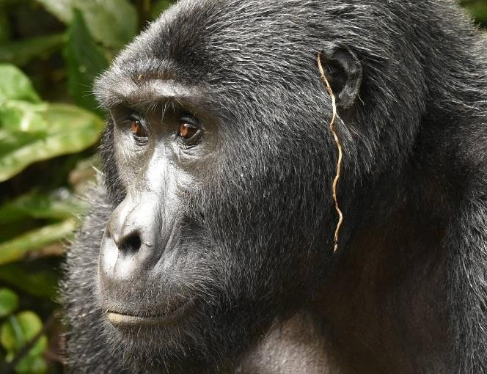
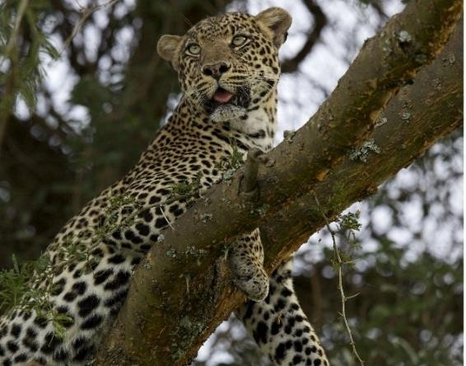

This ten day safari includes a thrilling visit with the Mountain Gorillas in Bwindi Impenetrable Forest National Park, chimpanzee tracking in both Kibale National Park and Kyambura Gorge, multiple game drives in Queen Elizabeth National Park with its wide array of wildlife, including the famous tree climbing lions, a boat cruise on the Kazinga Channel, and an optional visit to Ngamba Island Chimpanzee Sanctuary on the beautiful Lake Victoria.
Uganda boasts some of the best bird watching in Africa, with over 1000 different species, including the rare shoebill and the remarkable grey crowned crane.
Luxury accommodation, professional guides and custom-made safari vehicles - this safari will be the trip of a lifetime. Please note - two gorilla trekking options are available with this itinerary based on availability. Please make your request at the time of booking.

Quick Reference Itinerary:
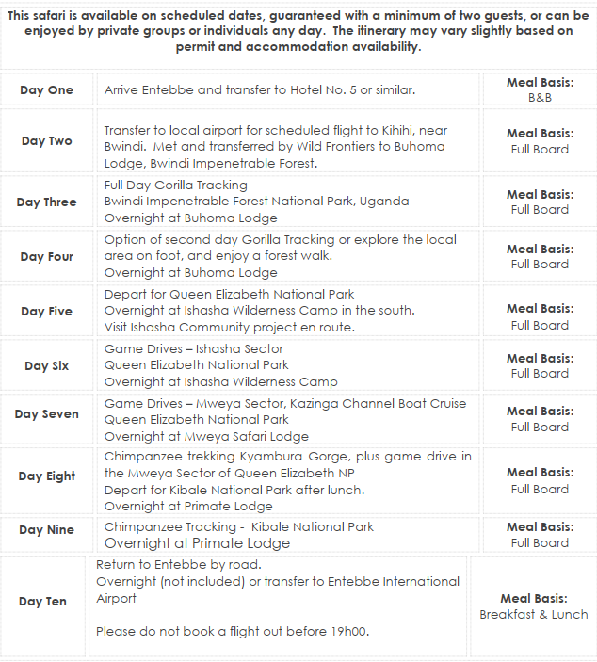

Detailed Itinerary:

Please note that itinerary and accommodation may vary depending on availability.

Day One
Arrive at Entebbe International Airport where you will be met by a tour representative and transferred to your accommodation. Depending on your arrival time, a half day trip to Ngamba Island Chimpanzee Sanctuary or a luxury boat cruise on Lake Victoria can be arranged at an additional cost. This could also be arranged at the end of your safari if you prefer.
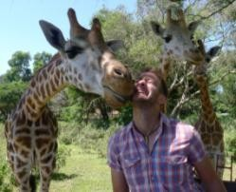
Other options include the Uganda Wildlife Education Centre in Entebbe, where there are a variety of visitors’ programmes including behind the scenes ‘work’ with the animals or a trip to the Mabamba wetlands in search of the rare shoebill. Ask when you book, if you are keen on this.
Entebbe is a small, quiet town located on the shores of Lake Victoria and is easy to explore on foot or local transport on motorbikes known as “boda bodas” or local taxis. Visit the Uganda Wildlife Education Centre where you can see and learn about Uganda’s native wildlife, local markets to buy clothes and crafts, curio shops for
souvenirs, and the Botanical Gardens on Lake Victoria where you can walk among beautiful trees, watch monkeys moving through the canopy above, and spot many indigenous bird species. Entebbe has a wide variety of restaurants serving many different cuisines as well as several bars and clubs where you can sample the local beer, catch a game of football and chat with the local Ugandans, known for their open and friendly nature.
Overnight at Hotel No. 5 www.hotelnumber5.com

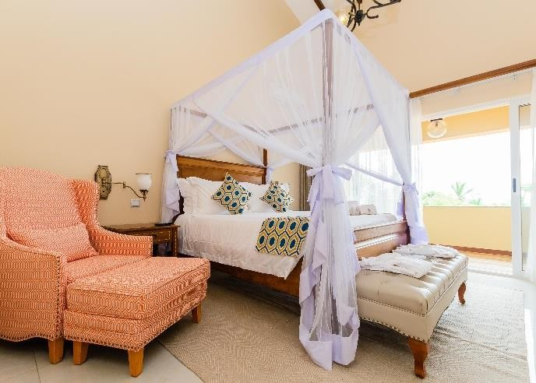
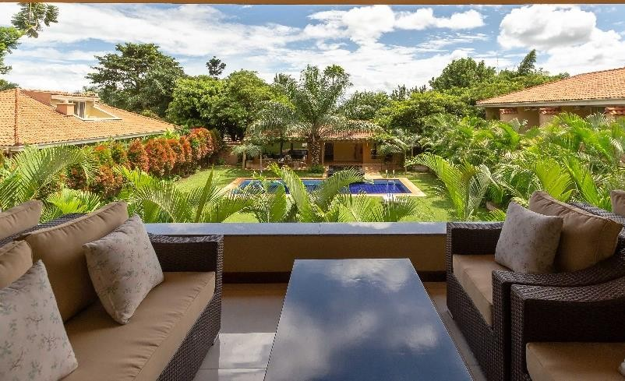

Nestled in the leafy suburbs of Entebbe, Hotel No.5 is a stylish boutique hotel. With all luxurious rooms opening onto the garden and swimming pool, this is a great option for guests looking for an intimate stay in a tranquil setting. Make yourself at home – unwind beside the swimming pool, pamper yourself with a spa treatment, or work up a sweat in the hotel gym. Attention to detail , outstanding dining and an attentive guest experience are synonymous with Hotel No 5.

Day Two
Depart your lodge, for the short drive to the Entebbe domestic airport for your scheduled flight to Kihihi airstrip, near Bwindi/Queen Elizabeth National parks.
The flight takes just over an hour (depending on the plane used) and on arrival you will be met by a tour representative and driven to Buhoma Lodge, located at Bwindi Impenetrable Forest. The drive to the lodge is through local villages and mountain roads – lovely scenery and very interesting en route!
Guests will have the opportunity for two days of gorilla tracking (pre-booking essential). Other activities that can be enjoyed in and around the park include forest walks, visits to a local school or orphanage or Batwa pygmy village, and curio shopping.
Bwindi National Park, located in south western Uganda on the edge of the Great Rift Valley, is considered the most diverse forest in Uganda. The area, one of the few large expanses of forest in East Africa, where lowland and mountain habitats meet, contains a dense ground cover of herbs, vines, and shrubs. Home to over 120 mammals, 345 species of birds, 200 species of butterflies, and 160 species of trees, Bwindi is one of the richest ecosystems in East Africa. The park contains almost one half of the world’s population of the endangered Mountain Gorilla, making it an extremely valuable conservation site. Bwindi is also home to several endangered bird species with very limited ranges, and acts as an important catchment area for many rivers, supplying water for agriculture in the surrounding region.
Buhoma Lodge www.ugandaexclusivecamps.com

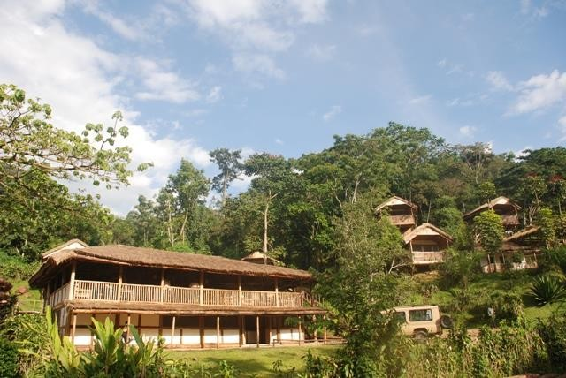
Buhoma Lodge commands spectacular and uninterrupted views of the Bwindi Impenetrable Forest National Park home to the rare and elusive Mountain Gorilla. We offer a top quality, intimate lodge for our guests’ enjoyment in this area. Situated within the National Park, Buhoma Lodge is a short distance from the meeting point for gorilla tracking and other activities in the area.

Ten comfortable cottages have been carefully built, each with its own private verandah, allowing wonderful views of the forest canopy of the National Park. Inside the spacious cottages you will find comfortable beds, a well appointed
en suite bathroom with flushing toilet and a hot shower and also some rooms with bath tubs. An elevated lounge area, complete with bar and dining facilities, offers a cosy, comfortable environment, to discuss the day’s activities around the fireplaces which add atmosphere and warmth in the cool evenings.

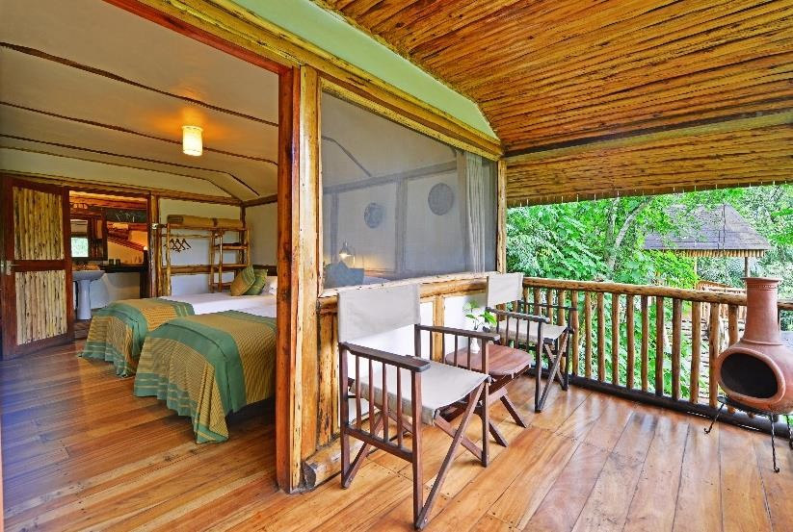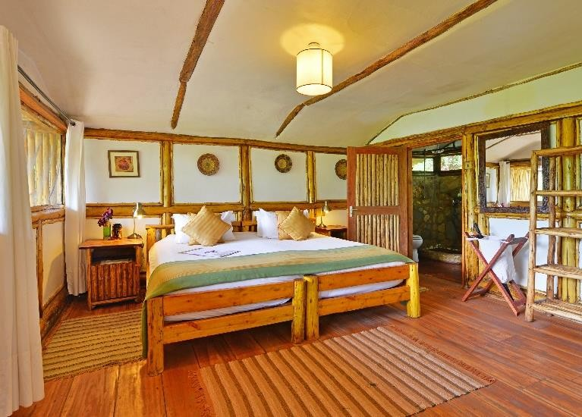

As part of our commitment as an organization with a responsible tourism policy we have designed the lodge using sustainable local materials where possible, with the emphasis being on natural products, which has in turn given support to the local communities and businesses. Supplies are obtained from as nearby as possible from local sources and staff are also generally recruited locally and trained on site. Our water supply is gravity fed and solar power is used for lighting with power points limited to a central area allocated for recharging cameras and videos.

Meals are freshly prepared with many local ingredients, offering a balance of international and locally flavoured cuisine with meals being of several courses. Our bar has a selection of local and imported beverages and our friendly local staff will attend to your needs.

Hot beverages are available throughout the day on a self service basis, but, are delivered to your cottage with early morning wake up calls as required, allowing you to awake gently and savour the early morning sounds of the forest.

Day Three
Gorilla Tracking - Bwindi Impenetrable Forest National Park
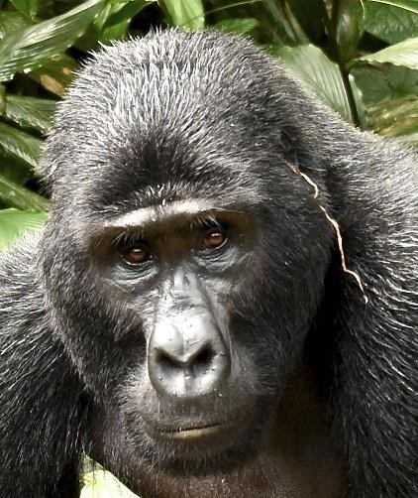
Following breakfast at the lodge, you will walk down to National Park Headquarters to meet your guides for the day and begin your gorilla tracking experience. Experienced guides and trackers will accompany your party on an early morning trek into the dense rain forest on the mountain slopes*. The journey, through dense foliage and up steep climbs, is abundantly rewarded with the lifetime experience of viewing mountain gorillas in their natural habitat. You will have an opportunity to be within meters of these magnificent apes, sharing in their daily lives and experiencing their day-to-day activities. Mountain gorillas are extremely rare with only an estimated 850 remaining in the wild. This is an experience you won’t soon forget! *Some of the gorilla families are located in an area which you will need to travel to by vehicle, but don’t worry – we will transport you there!

Following the trek, return to your accommodation and, if time allows, take a guided afternoon forest or community walk. Please note: tracking may be fairly strenuous with treks up to six hours or longer, at high altitudes, not uncommon. Also, mountain gorillas are wild animals and, as such, sightings cannot be guaranteed. However viewing success rates are over 95%. Please refer to our detailed information sheet for more detailed information on Gorilla Tracking requirements, conditions, and considerations.

Day Four
Those with pre-purchased permits will depart for a second gorilla tracking experience following breakfast at the lodge. Depending upon individual itinerary schedules, guests not tracking gorillas may wish to enjoy other activities available in the area such as a forest walk, a visit to a local school/orphanage or Batwa pygmy village, and curio shopping.

Forest Walk (Optional)
Embark on a walk through tropical rainforest with experienced wildlife guides. Enjoy scenic views, the sights and sounds of the rain forest, ample opportunities for bird watching and glimpses of the many monkey species living in the park as they move through the forest canopy.

Village Community Walk (Optional)
Embark on a community walk through the local villages surrounding Bwindi Impenetrable Forest. Optional activities include visits to a traditional home, local orphanage or school, banana brewing demonstrations and even meeting traditional medicinal healers. This three to four hour walk is easily tailored to your individual schedule and interests.

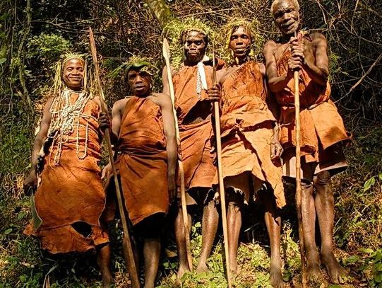
Batwa Cultural Experience (Optional)
Embark on a three to four hour hike to a Batwa village in the midst of Bwindi Impenetrable Forest. This amazing encounter will allow you the opportunity to meet Batwa elders and their families and learn about their daily lives. Through the assistance of a skilled interpreter you will discover the unique traditions and practices the Batwa people including their deep attachment to the forest, the cuisine they enjoy, how they harvest their food, the style of their homes, and their burial rites. Visitors are even given the chance to learn how to light a fire with just a stick and how to shoot a target with traditional weapons.
- Please note that days 3 and 4 are interchangeable depending on when we can secure gorilla permits *

Day Five
This morning we depart Bwindi Impenetrable Forest National Park and travel (2-3 hours) to Ishasha in the southern part of Queen Elizabeth National Park.
Time permitting, during our drive from Bwindi to Ishasha, we may visit a Community Project on the border of Queen Elizabeth National Park. Here the local people allow you to enjoy some time in their homesteads, as well as see some of the crops and curios they produce, how they prepare their food while sharing stories about the Bakiga people and lifestyle.
Afternoon game drives will be enjoyed in the Ishasha area, looking for the huge herds of buffalo, elephant, Uganda kob and of course the famous tree-climbing lion typically found in the area.

Overnight at Ishasha Wilderness Camp
Ishasha Wilderness Camp www.ugandaexclusivecamps.com

Ishasha Wilderness Camp is situated inside the Southern Ishasha sector of Queen Elizabeth National Park on the Ntungwe river, and is an idyllic retreat for people who truly enjoy the wilderness. This exclusive camp offers quality accommodation and services in this unspoilt remote southern sector of Queen Elizabeth National Park famous for its tree climbing lions that can sometimes be spotted resting in the branches of the large fig trees in the area.

Each of the ten spacious framed canvas rooms, situated in the wooded area besides the river, is comfortably furnished and with large mosquito netted beds, its own private en suite bathroom and dressing area providing running water, hot water ‘bush’ showers and a flushing eco-friendly toilet.
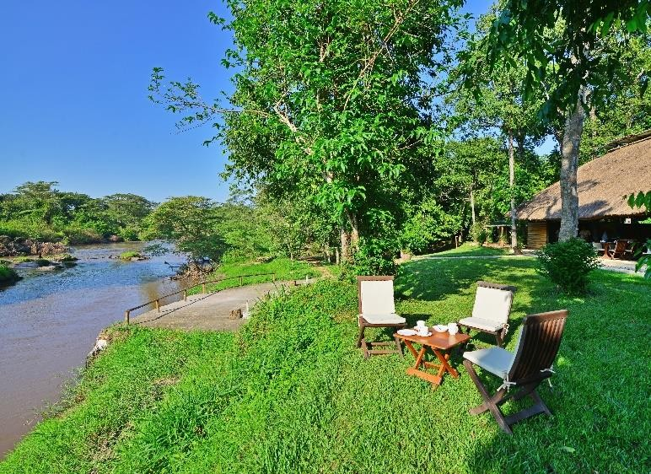
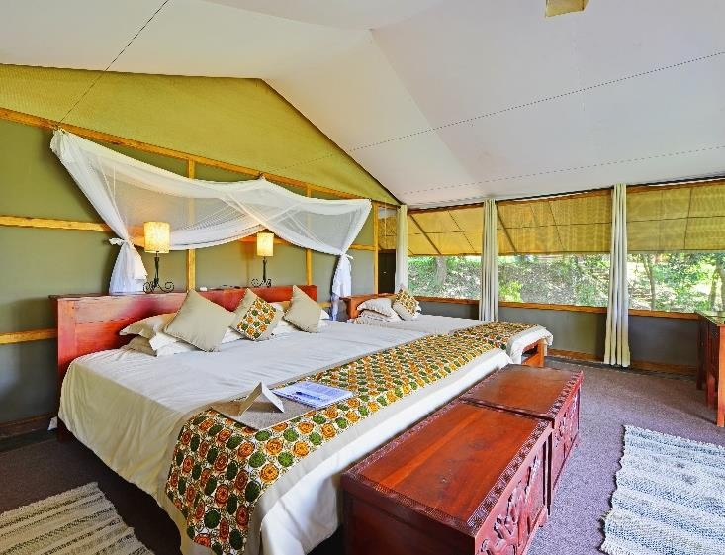

A central lounge and dining area, under a cool thatched roof, provides a comfortable environment for meals and relaxing during the day. A shaded area beside the river offers al fresco dining and an evening ‘fireplace’ for guests to relax with sundowners and share their day’s experience.

As the camp is within the National Park, we have designed it to be as low impact as possible with low usage of water, power and other resources. Solar power is used for lighting with power points limited to a central area allocated for recharging cameras and videos.

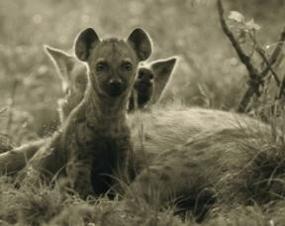
Meals are freshly prepared with many local ingredients, offering a balance of international and locally flavoured cuisine with all meals being of several delicious courses. Our bar has a selection of local and imported beverages and our friendly local staff will attend to your needs. Hot beverages are available throughout the day on a self-service basis, and are delivered to your tent with early morning wake up calls as required, allowing you to savour the early morning sounds of the ‘bush awakening.

Highly recommended to book in advance are the bush sundowners and the bush breakfast, both hugely memorable experiences in beautiful settings.

Day Six
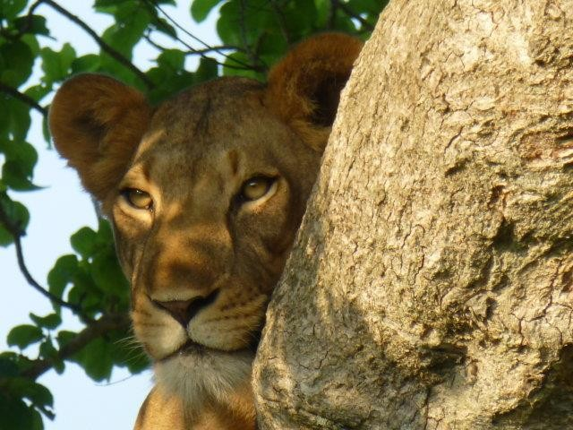
Spend the day enjoying game drives in the Ishasha sector of Queen Elizabeth National Park.
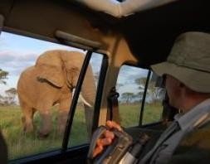
Queen Elizabeth National Park spreads over 1,978 sq km in the western arm of the Great Rift Valley and is home to a wide variety of wildlife including elephants, leopard, lions, hippos, buffalo, Uganda kob, baboon, and many species of birds. With both a riverine and savannah habitat, the park includes the southern Ishasha area with the massive Maramagambo, one of the largest surviving natural forests in Uganda. The northern Mweya area, traversed by the equator and dominated by the scenery of crater lakes, is often occupied by large flocks of flamingos.

Game Drives – Ishasha Sector
The Ishasha area of Queen Elizabeth National Park is rich with wildlife including warthog, water buck, bush buck, leopard, Ugandan kob, elephants, countless bird species and even the rare giant forest hog. The Ishasha sector of the park is known for its famous tree climbing lions sometimes found lying about in the branches of the native fig trees.
Overnight at Ishasha Wilderness Camp

Day Seven
Game Drives – Mweya Sector
Head north toward the ‘Mweya’ sector of the park which is rich with wildlife, visitors will find vast numbers of Uganda’s unique and strange Euphorbia, or “candelabra” tree. The many nearby crater lakes and mountain ranges provide a beautiful backdrop for your journey
In the afternoon enjoy a leisurely boat cruise along the Kazinga Channel, a 32-kilometre long natural channel linking Lake Edward and Lake George. Kazinga’s shores are dotted with herds of lazy buffalo, pods of hippos wallowing without a care, and countless bird species. Drift past local fishing villages and soak up the peaceful tranquillity of this beautiful African day. (Cruise normally departs at 14h00, although this depends on availability when booking and is subject to change –no drinks/ snacks included on boat)
You may encounter herds of elephant, buffalos and antelopes, families of warthogs, large groups of hippos, and crocodiles basking on the shore. Kazinga’s shores are a haven for numerous birds, including many migratory species as they make their way south to warmer climates. The cruise also provides a spectacular view of the beautiful Mweya Peninsula and life in local fishing villages set along the banks.
Overnight at Mweya Safari Lodge www.mweyalodge.com
Located on a peninsula overlooking the Kazinga Channel on one side and the Rwenzori Mountains on the other, this well positioned lodge provides some of the best accommodation and service facilities in western Uganda. Amenities include a swimming pool, the Tembo bar and an elegant air-

conditioned restaurant with global cuisine. Breakfast is served on the lodge’s outdoor terrace with
views of the Kazinga Channel below.

Day Eight
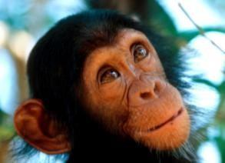
This morning we will travel early to the Kyambura Gorge to enjoy Chimpanzee trekking. After this activity, we depart to the airstrip nearby for the flight to Entebbe

Chimpanzee Tracking
This activity will generally take place in the morning. The forest is alive with noise and you should be lucky enough to see the habituated chimps during your trek.
A 3-4hour drive takes you to Kibale Forest, comprising an interesting blend of lowland tropical
rain forest, montane forest, and mixed tropical deciduous forest. In addition to forest, you will also notice areas of grassland and of swamp. The forest is rich in wildlife and is most noted for its primate population.
These include red-tailed monkey, diademed monkey, olive baboon, chimpanzee, and black and white colobus. The birdlife is also abundant, with close on 300 species identified here. The forest is also home to 144 species of butterfly and a diverse population of moths and other insects
Overnight at Primate Lodge or similar including all meals.
Primate Lodge www.ugandalodges.com
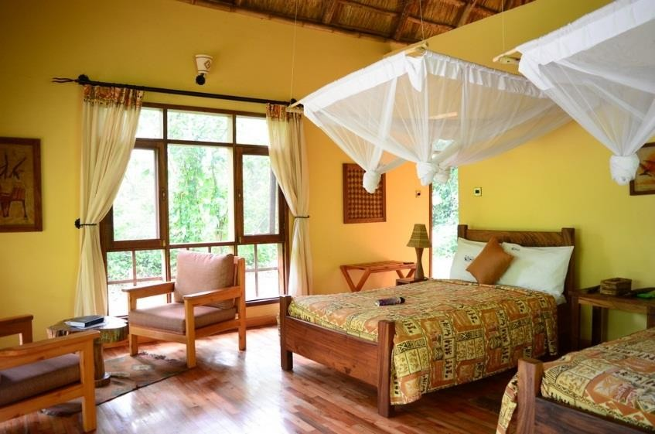
Located in Kibale National Park, less than 500 meters from the start of the park’s chimpanzee tracking, Primate Lodge offers sixteen comfortable and spacious en suite cottages. Each tastefully decorated cottage sits on a raised wooden deck and has its own private veranda looking into the forest, African style beds, large windows and hot and cold running water. The lodge’s restaurant and bar with comfortable chairs, sofas and soft cushions and a fireplace for chilly evenings makes it a perfect place to dine and relax after the day’s activities.

Day Nine
Chimpanzee Tracking
This activity will generally take place in the morning. You will either be driven or walk down to the Kibale Forest National Parks’ headquarters to meet your guides for your morning’s chimp tracking experience. The forest is alive with noise and you should be lucky enough to see the habituated

chimps during your trek. Sometimes they move quickly through the forest, other days you may be lucky enough to catch them resting, interacting or eating near the forest floor.
Overnight at Primate Lodge

Day Ten
Depart after an early breakfast and drive back to Entebbe, arriving late afternoon. Rest of the afternoon/evening is at leisure.

Overnight extension = optional. If staying in Entebbe, please request at time of booking safari. If departing Entebbe the same night, please note your vehicle returns to Entebbe late afternoon (approximately 16h00/17h00) so DO NOT book flights departing prior to 19h00 in order to allow time for security, check in and any delays.

Includes:

  - Airport transfers (Entebbe/return)
  - One way domestic flights from Entebbe to Kihihi/QENP on a scheduled flight
  - 4x4 transport with English speaking local driver/guide as above
  - Accommodation and meals as above (full board on safari, bed and breakfast in Entebbe)
  - Soft drinks, local beers, spirits and house wines whilst at Buhoma Lodge and Ishasha Wilderness Camp.
  - Bottled water in safari vehicle
  - Community visit en route from Bwindi to Ishasha
  - All park entrance fees
  - Boat cruise on the Kazinga Channel
  - Game drives in Queen Elizabeth National Park
  - Full liability insurance cover
  - 24 hour emergency contact

Excludes:

  - Gorilla Permit of USD600 per trek Bwindi – must be pre-booked/prepaid
  - Chamburu (Kyambura Gorge) chimpanzee permits (USD 50 each)
  - Kibale chimpanzee permits (USD 150 each)
  - Optional extra of Forest Walk Bwindi (USD 70 pp including park fees)
  - Optional extra of Community Visit Bwindi (USD 30)
  - Optional extra of Batwa Pygmies Community Visit (USD 85)
  - Optional additional permits including trek transfer and facilitation (USD 670)
  - All international flights and airport taxes
  - Personal expenses such as porters, drinks, tips, visas and travel insurance
  - Services/activities/meals not included above

Please note - two gorilla trekking options are available on this itinerary. Please specify your permit requirements at time of booking.

GORILLA TREKKING AREAS & PERMIT ALLOCATIONS:

On our scheduled departures, we typically buy permits for Buhoma & Ruhija, which are accessible from Buhoma area. One of the Buhoma families, and the Ruhija families, require a road transfer to the start point. This does not deviate from the enjoyment of the trek (and could be considered as enhancing your trip as you are seeing a different part of the region). Furthermore, your permit may be organised for day 3, or 4, of your safari. It will depend on availability at the time of purchase.

IMPORTANT ADDITIONAL INFORMATION:

Health: Yellow fever & malaria prophylactics are required.

For gorilla/chimp trekking it is imperative that you are healthy and free of any disease or virus – officials do have the right to refuse entry if you are found to have or show any signs of communicable illnesses.

Should you opt to spend time participating in the UWEC Wildlife Integration programmes, you may require additional inoculations and health clearances. Please enquire at the time of booking. These activities must be booked well in advance.

Visas: Most nationalities require a visa to enter Uganda which must be applied for and paid for online prior to arrival. A single entry tourist visa is USD 50 per person, single entry. Passports must be valid for a minimum of 6 months or 12 months in the case of UK nationals. The EAC Visa allows entry into Uganda, Rwanda and Kenya for one fee of USD100 – handy if you are visiting all three regions.

Travel insurance: Travel Insurance is compulsory
